Reading
MODULE 1: 20 mins.

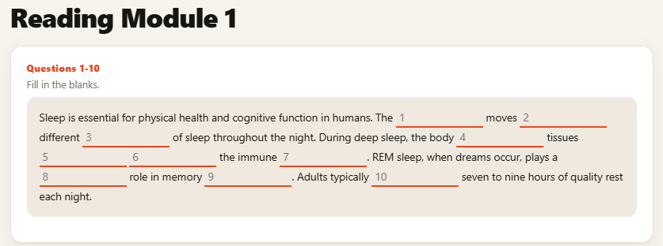

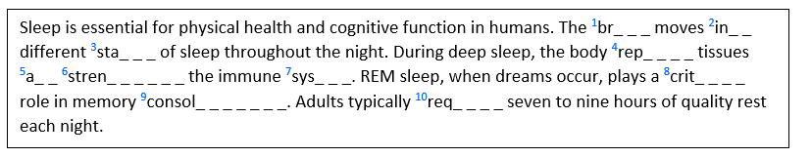

Reading Task 1
There should have cut lines “ _ _ _ “ with the correct missing number of the word needed“

Reading Task 2 (Read in Daily Life)
Information or reading passage should be on the left side and questions should be on the right side.
Subject: Community Garden Opening

Dear Ms. Alvarez,

The Riverside Community Garden is now fully prepared and ready for use starting April 1. Garden space assignments will be emailed to registered members by March 25. Please bring your own seeds and gardening gloves. Water hoses and wheelbarrows are available at the tool shed.

Best regards,

Thomas Bergman Community Programs

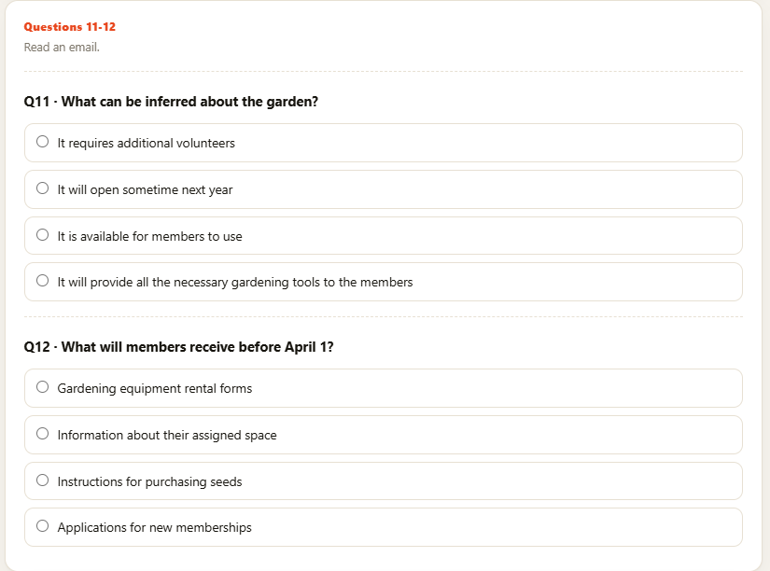

Reading
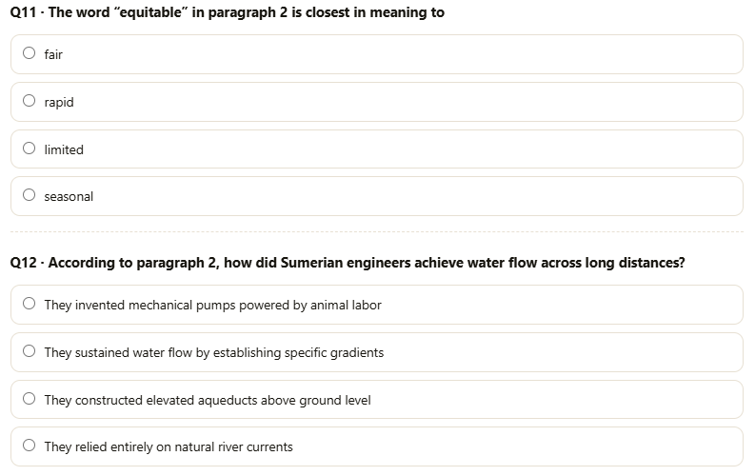
MODULE 2: 10 mins. (Time limit)
Ancient Irrigation Systems

Ancient Mesopotamian civilizations developed sophisticated irrigation systems that transformed arid river valleys into productive agricultural land. Beginning around 6000 BCE, farmers in the region between the Tigris and Euphrates rivers constructed canals to divert floodwaters onto their fields. This innovation allowed populations to grow beyond what rainfall alone could support, laying the foundation for the world’s earliest cities.

The Sumerians refined these techniques into elaborate networks of primary canals, secondary channels, and distribution gates. Engineers calculated precise gradients to maintain steady water flow across distances of many kilometers without mechanical pumps. Storage basins collected excess water during floods for release during dry months. Records on clay tablets show that dedicated officials managed water allocation, resolving disputes between farmers and ensuring equitable distribution throughout the growing season.

Despite their ingenuity, these systems faced persistent challenges. Irrigated fields gradually accumulated salt as water evaporated and left minerals behind, reducing soil fertility over centuries of continuous cultivation. Silt buildup required constant canal maintenance, demanding substantial labor from the population. Political instability could interrupt this maintenance, sometimes causing rapid agricultural decline. These vulnerabilities help explain why several Mesopotamian city-states experienced dramatic population collapses even at the height of their technological sophistication.

TOEFL Listening Task 1
Task 1: The speaker will say the question and it will not be shown in screen but only picture instead and then the option to choose will appear on the right side given the 20 secs time limit.

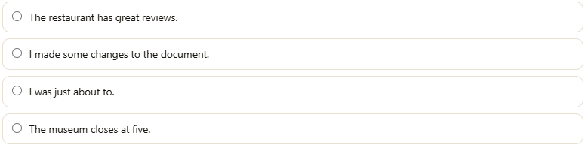

The same with task 1 the conversation and announcement will be done by the speaker and each question will appear after the conversation given 20 SECS. Limit TO ANSWER.

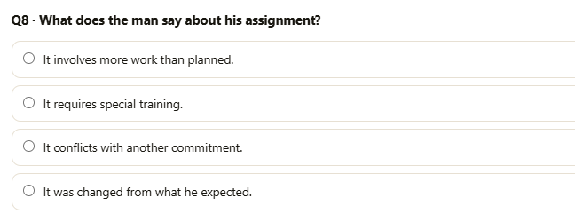

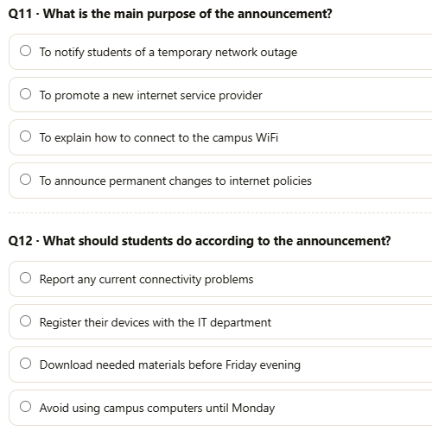

(Announcement)

(Academic Talk)

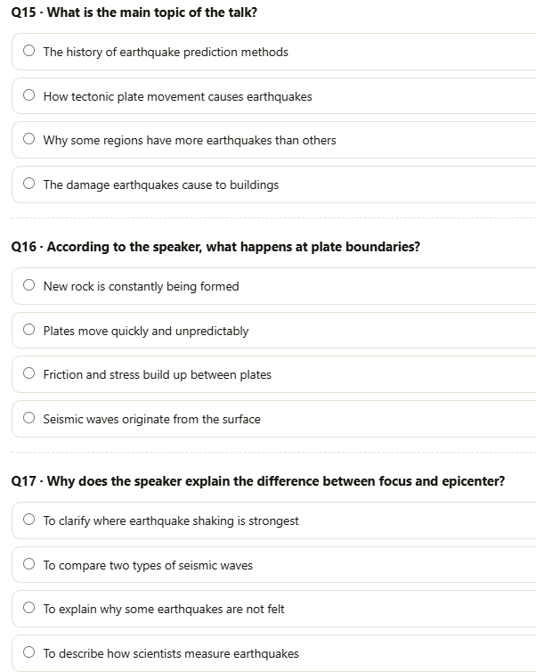

In Writing Task 1 The WORDS SHOULD BE DRAG to the blank TO CREATE A SENTENCE with time limit of 7 MINS. For 10 questions.
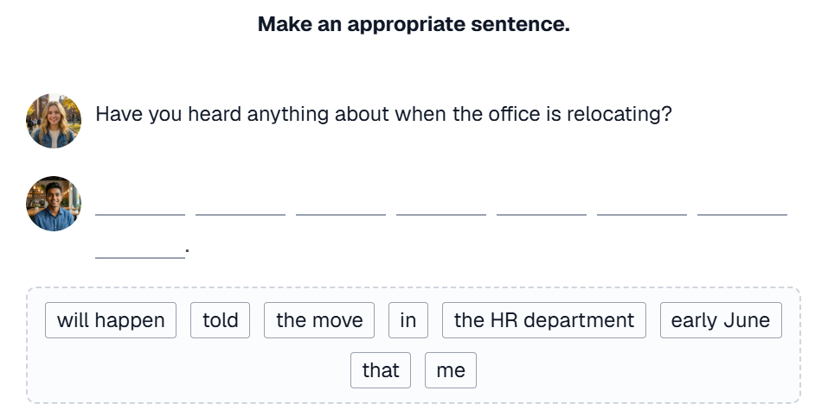

Writing Task 2 is writing an email. Task should be on the left side and writing response should be on the right side with the time limit of 7 MINS.
And has a word counter.

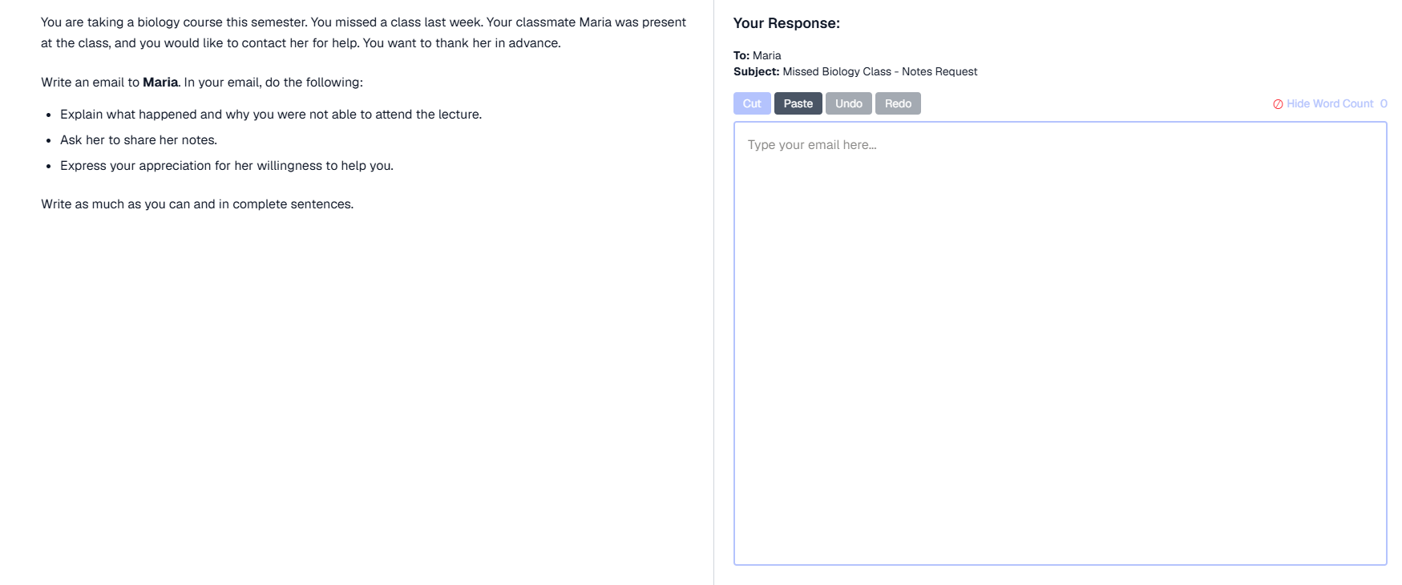

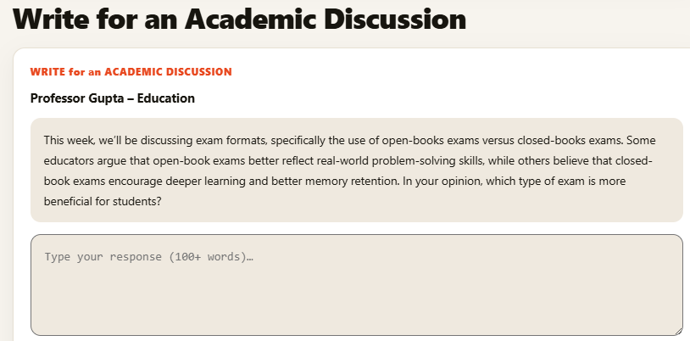
In Writing Task 3 is academic writing the same with task 2 the task should be on the left side and the writing response on right side with the time limit of 10 MINS.
And has a word counter

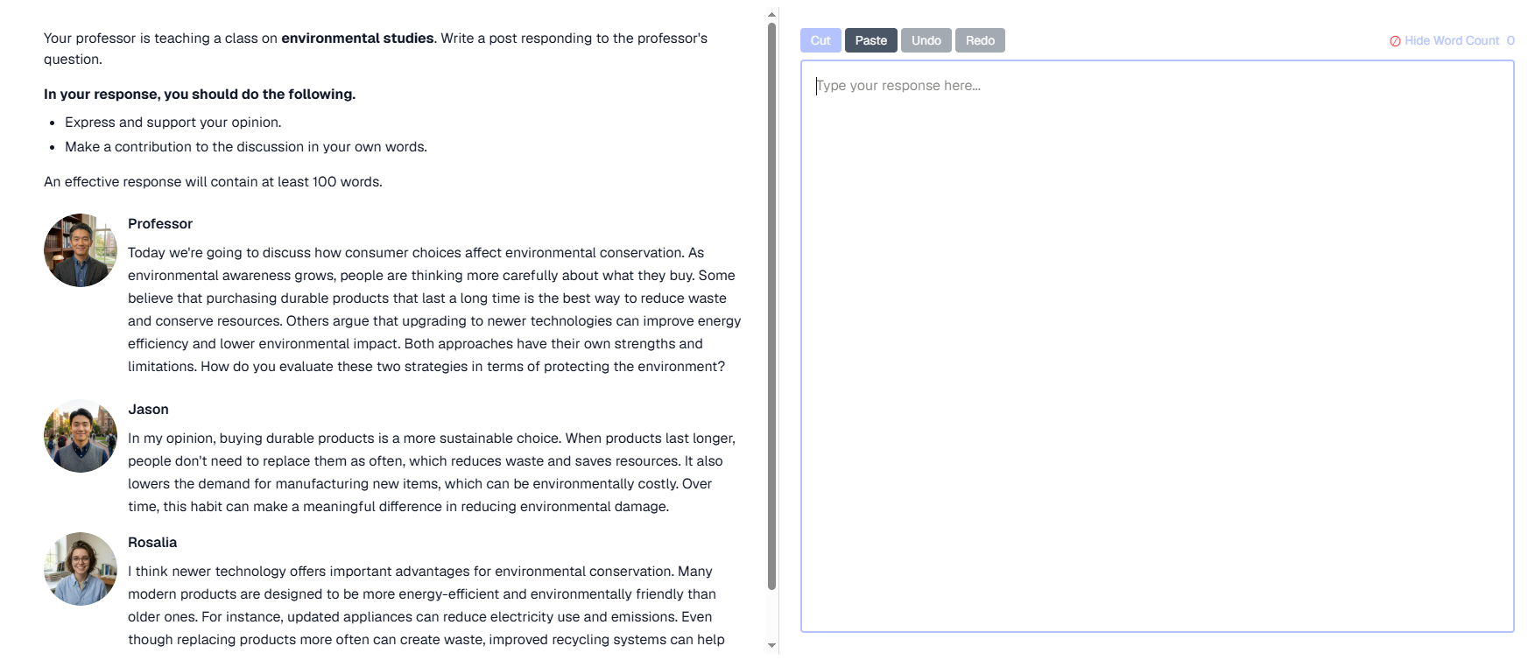

TOEFL Speaking Task 1 is a listen and repeat there are 7 statements you’ll need to repeat. At first there will be a scenario which is presented first and then the first statement will be given with the picture guide and the first statement will follow and you are only given 8 secs to repeat for the first 2 numbers, And 10 secs for the 3rd -5th statements and 12 secs to the 6th-7th statements.
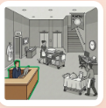

TOEFL Speaking Task 2 is an interview type. At first there will be a scenario which is presented first and then the first question is presented, then you are give 45 secs. to respond.


